**Autumn Salad of Pears, Gorgonzola and Walnut Vinaigrette**

**Makes 2 Servings**

**Walnut Halves, toasted ¼ cup**

**Belgian endive 1 head**

***Trimmed, cut crosswise on a bias***

**Radicchio, torn ½ head**

**Watercress, stemmed 1 bunch**

**Flat Leaf Parsley, chopped 1 Tbsp**

**Spring Mix, assorted greens 2 cups**

**Gorgonzola Cheese 4 oz**

***Crumbled or 1” cubes***

**Bartlett Pears 1 each**

***Halved, cored and cut lengthwise***

**Kosher Salt and Black Pepper to taste**

**Walnut Vinaigrette**

**Yields: ½ cup**

**Red Wine Vinegar 2 Tbsp**

**Dijjon Mustard 1 tsp**

**Walnut Oil ¼ cup**

**Chives, minced 1 Tbsp**

**Coarse Salt and ground pepper to taste**

**In a medium bowl, whisk together the vinegar and the mustard until combined. Gradually whisk in the walnut oil until emulsified. Season with salt, pepper and chives. Cover and refrigerate until ready to use. Whisk well before using.**

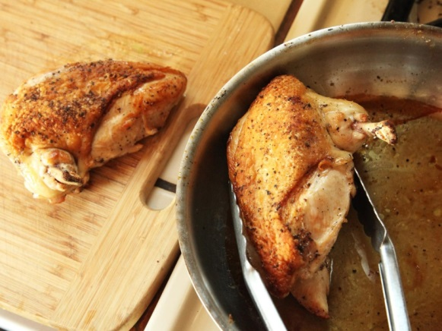5.0



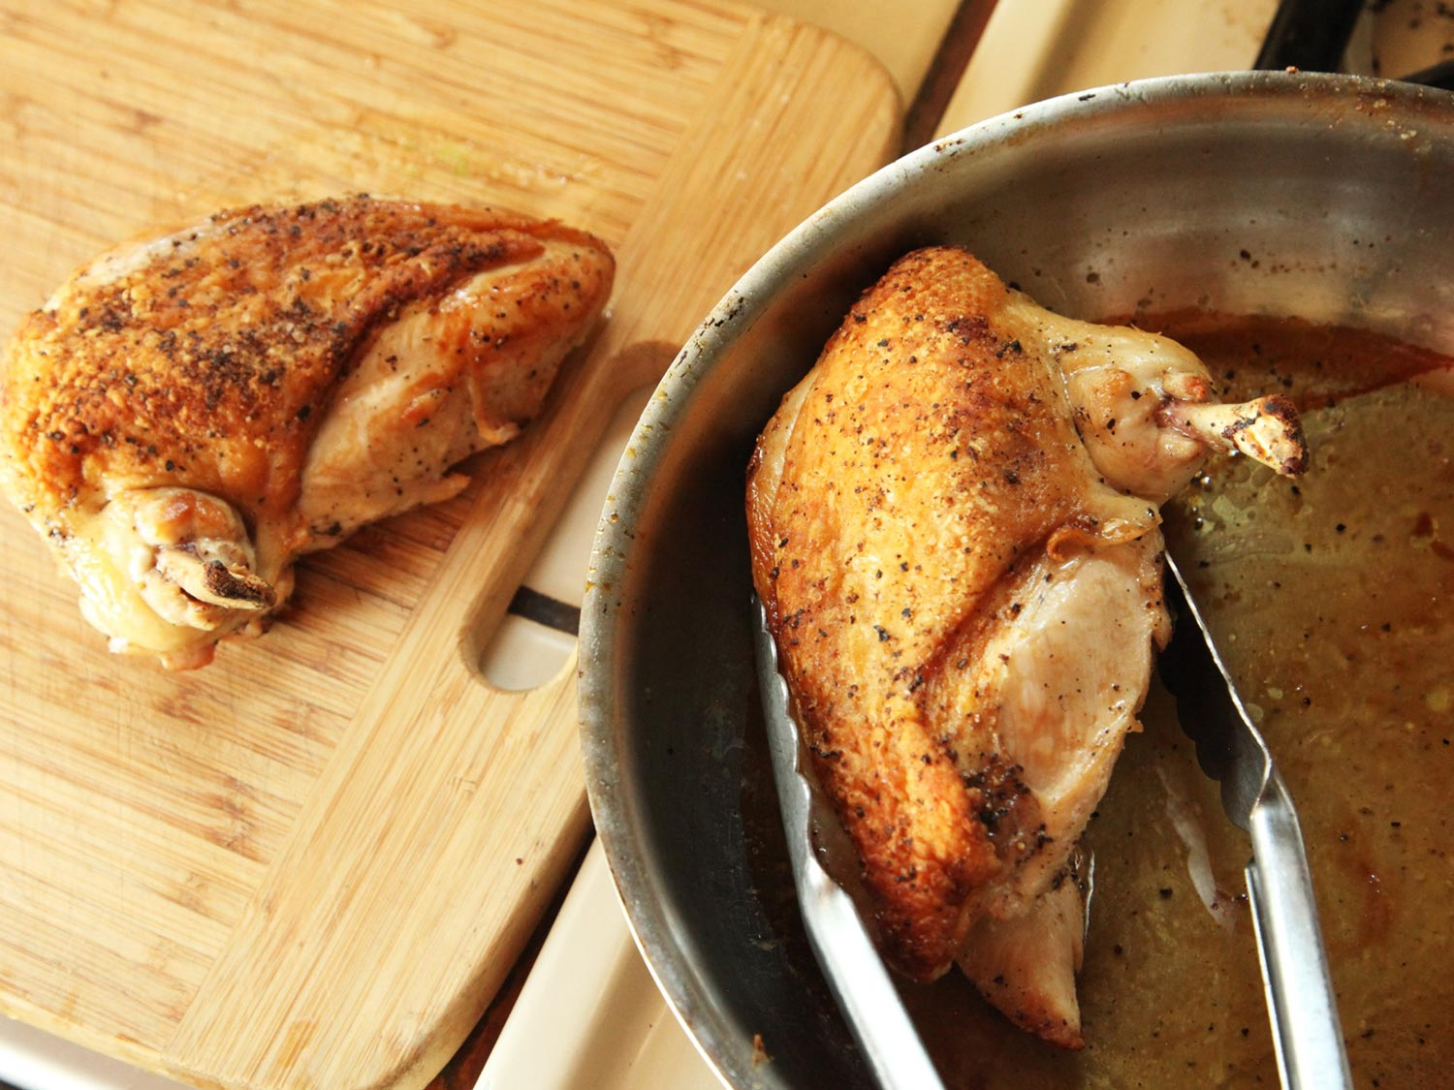[](http://www.google.com/url?sa=i&rct=j&q=&esrc=s&source=images&cd=&cad=rja&uact=8&ved=0ahUKEwilge_embPSAhXDTCYKHUIABHUQjRwIBw&url=http://www.seriouseats.com/2015/04/airline-chicken-breast-knife-skills.html&bvm=bv.148073327,d.eWE&psig=AFQjCNFQoOUaJLp5chQ_PEhp8nVky2uZVA&ust=1488385137011854)Bottom of Form

# **Chicken Breast with Chorizo Stuffing & Pan-Fried Polenta**

### Ingredients

One 3-ounce dry-cured chorizo sausage

1/4 cup plus 3 tablespoons extra-virgin olive oil

5 large white mushrooms, ends trimmed, very thinly sliced

Salt and freshly ground pepper

2 medium leeks, white and tender green parts only, very thinly sliced crosswise

1 1/2 packed cups baby spinach

1/4 cup coarsely shredded young pecorino cheese, such as Pecorino Toscano

2 Airline Chicken Breast, Skin on

As needed Panko Bread crumbs

1/2 cup fruity Pinot Noir

1/4 cup dry Marsala

1/2 cup chicken stock

2 tablespoons unsalted butter

1. Preheat the oven to 425°. Bring a small saucepan of water to a boil. Add the chorizo and simmer over low heat until softened, about 5 minutes. Transfer the chorizo to a plate and let cool. Thinly slice the chorizo crosswise, and then coarsely chop it.
2. In a medium skillet, heat 3 tablespoons of the olive oil. Add the mushrooms in a single layer, season with salt and pepper and cook over high heat until browned on the bottom, about 4 minutes. Add the leeks, cover and cook over moderate heat, stirring occasionally, until softened, about 5 minutes. Add the chorizo and cook, stirring, for 1 minute. Add the spinach and stir just until wilted. Transfer the stuffing to a bowl and let cool slightly. Stir in the cheese and season with salt and pepper. Thicken with panko bread crumbs as needed.
3. Using a thin, sharp knife, cut a pocket in each chicken breast: Insert the blade 2 inches into the center of the chicken breast, cutting horizontally from one side to the other without cutting completely through. Generously fill the chicken breast with the stuffing and secure the openings by threading them closed with bamboo skewers or tying with butchers twine. Break off the ends of the skewers that protrude from the meat.
4. Heat 2 tablespoons of the olive oil in each of 2 large skillets. Season the chicken breast with salt and pepper. Cook both chicken breasts in one skillet over moderately high heat, turning once, until nicely browned, about 5 minutes. Transfer the skillet to the oven and cook until internal temperature reaches 165 on a stem thermometer Transfer the chicken breast to a warmed platter.
5. Pour off the fat from each skillet and set the skillets over moderate heat. Add the Pinot Noir to the skillet and scrape up any browned bits stuck to the bottom and simmer for 1 minute. Add the Marsala and stock and simmer until slightly reduced, about 3 minutes. Off the heat, whisk in the butter and season the sauce with salt and pepper.
6. Remove the skewers or string from the meat. Spoon the pan sauce onto the warmed plates and serve with the Fried Polenta.

# **Pan-Fried Polenta Slices**

### Ingredients

1 quart Chicken Stock

1 cup polenta

2 tablespoons unsalted butter, plus more for frying

1/2 cup (1 1/2 ounces) freshly grated Parmigiano-Reggiano cheese

Salt and freshly ground pepper

Olive oil for frying

### Instructions

1. Lightly oil a 6-by-10-inch glass or ceramic dish, 3 cups.
2. Bring the Stock to a boil in a large saucepan. Slowly whisk in the polenta. Cover and cook over low heat, whisking often, until thickened, about 10 minutes.
3. Stir in the butter and cheese, season with salt and pepper and, while hot, pour into the dish. Let stand until room temperature and firm, about 30 minutes. Cover with plastic wrap and refrigerate overnight.
4. Cut the polenta into 1-inch-thick slices. In a large non-stick skillet, melt butter in olive oil. Fry the polenta slices over moderate heat until golden brown and crisp, about 8 minutes per side.

**Vegetable Accompaniment**

Available main ingredients may include but not limited to:

* Asparagus, Green beans, Carrots and Broccoli as well as supplementary vegetables.
* Various fresh herbs & dried spices.